VPro Quick Start
October 4, 2016

VPro runs on Microsoft Office
VPro is built using components from Microsoft Office, primarily Access and Excel but also draws on resources from other bits of Office. VPro is happiest running on Windows 7 and Office 2010 but with some coaxing can be persuaded to run on some older and newer versions.

Access is a container
The bulk of VPro resides in an Access database. You can think of the Access database as a container that can include tables, queries, forms and code. Much of your interaction with VPro will be using menu items and forms but you can also create your own custom views of the data using queries – perhaps better left until you are comfortable using Access.

Frontend / backend design
We refer to the design of VPro as a frontend/backend. The frontend is the VPro program and contains system tables, forms, queries and code modules. The backend is where your data resides. VPro is designed this way to separate your data from the program so that we can update and repair your copy of VPro without endangering your data (though we highly recommend backing up your data database(s) regularly). VPro attaches or links your data to the program and manages those links using the Data Centre menu described below.

VPro is a relational database
Your data will be organized into a series of tables that will be joined using an identification key. In a VPro project (more on projects below) this key is the plot number that you assign to each plot. The relationship between your tables is managed by VPro so that you don’t have situations where you have vegetation data without a corresponding plot record.

VPro Projects
Each VPro project contains seven tables and each has a name with an extension that informs the user as to its contents. The left portion of the name is the project name. For example, Sample_Env represents the project Sample and contains environment data. Here is a list of the extensions and the entity type for each project table:
- _Env contains data describing the plot location and attributes
- _Veg is your vegetation data
- _Humus has records for each humus soil horizon
- _Mineral has records for each mineral soil horizon
- _Other is a table that allows for customization of your project
- _Metadata contains a description of the project
- _Audit table tracks changes made to the data in form view
We will be looking at how to create, attach, un-attach and rename projects below.

VPro Menus
VPro uses two menu systems that the user uses to interact with the program. The floating Data Centre menu
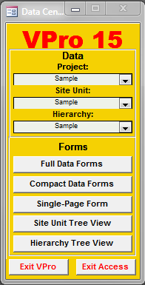
It is with this menu that you will interact with some of VPro’s most common items. VPro can have multiple projects attached and from here you can select the one you wish to work with.
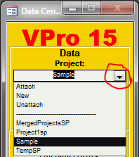
Clicking the combo box arrow will reveal the commands to attach, create and un-attach projects. It is also here that you can select from the list of attached projects.

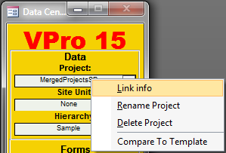
Right-clicking the project name will give you a popup menu from which you can reveal the location of the project database, rename the project, delete a project, or compare the project structure to that of the current version.
From the Data Centre you have quick access to some of the most popular data forms where you can add to and edit data.
The ribbon menu is a much more in-depth list of VPro functions.
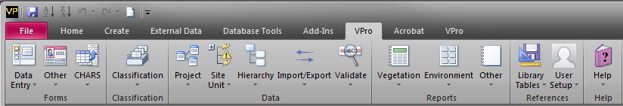

VPro projects
Creating
Attaching and un-attaching

The site unit tables

The hierarchy

Entering / Editing / Viewing data

Reporting tools
Excel as a object

Splintering a project

Merging projects

